**--creating table iplball**

create table ipl_ball (id int,inning int,over int,ball int,batsman varchar(100),non_striker varchar(100),bowler varchar(100),batsmen_runs int,extra_run int,total_runs int,is_wicket int,dismissal_kind varchar(100),pyaler_dismissal varchar(100),fielder varchar(100),extras_type varchar(100),batting_team varchar(100),bowling_team varchar(100) );

**--copy data from csv in ipl ball**

copy ipl_ball from 'C:\Program Files\PostgreSQL\16\data\copy data\IPL_Ball.csv' delimiter ',' csv header;

**--making table of batsmen stats data**

create table batsmen_stats as select count(distinct (id)) as matches_played ,batsman,count(ball) as ball_played ,sum(batsmen_runs) as total_runs , sum(is_wicket) as times_out,

case when sum(is_wicket)>0 then (SUM(batsmen_runs) / NULLIF(SUM(is_wicket), 0)) else SUM(batsmen_runs) end AS average_runs,

(SUM(batsmen_runs) * 100.0) / NULLIF( COUNT(*) , 0) AS strike_rate , SUM(CASE WHEN batsmen_runs = 4 THEN 1 ELSE 0 END) AS fours,

SUM(CASE WHEN batsmen_runs = 6 THEN 1 ELSE 0 END) AS sixes,SUM(CASE WHEN batsmen_runs IN (4, 6) THEN 1 ELSE 0 END) AS total_boundaries from ipl_ball where not extras_type= 'wides' group by batsman;

**--showing demo data of batsmen stats**

select * from batsmen_stats ;

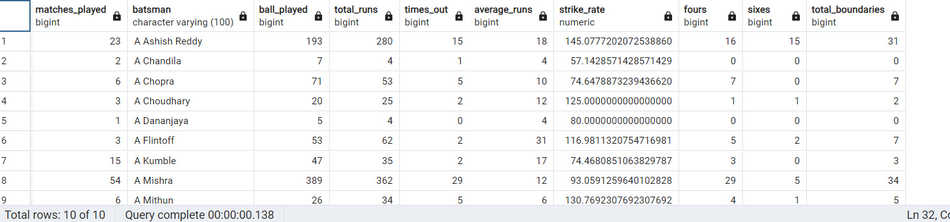

**-- creating table from bowler stats**

create table bowler_stats as SELECT bowler,

COUNT(DISTINCT id) AS matches_played,

COUNT(ball) AS balls_delivered,SUM(batsmen_runs + CASE WHEN extras_type NOT IN ('byes', 'legbyes') THEN extra_run ELSE 0 END) as runs_conseed,

(SUM(batsmen_runs + CASE WHEN extras_type NOT IN ('byes', 'legbyes') THEN extra_run ELSE 0 END) / (COUNT(*) / 6.0)) AS economy,

COUNT(ball) / NULLIF(SUM(is_wicket), 0) AS strike_rate,

SUM(is_wicket) AS wickets_taken

FROM

IPL_Ball

GROUP BY

bowler;

**--showing demo of table bowler_stats**

select * from bowler_stats ;

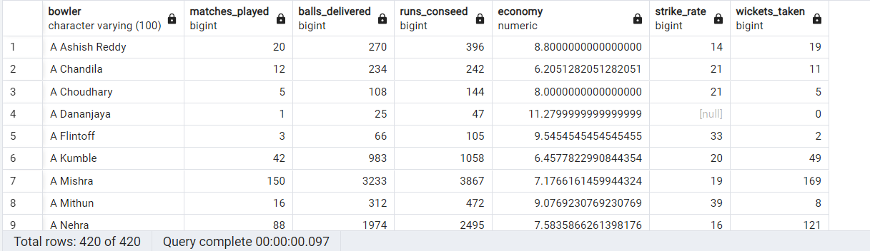

**/* Your first priority is to get 2-3 players with high S.R who have faced at least 500 balls.**

**And to do that you have to make a list of 10 players you want to bid in the auction so that when**

**you try to grab them in auction you should not pay the amount greater than you have in the purse**

**for a particular player.*/**

select batsman ,ball_played,strike_rate from batsmen_stats where ball_played>500

order by strike_rate desc

limit 10;

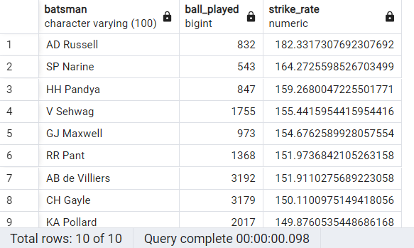 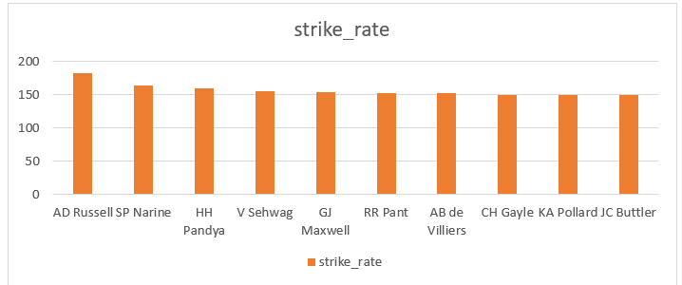

**/* Now you need to get 2-3 players with good Average who have played more the 2 ipl seasons.**

**And to do that you have to make a list of 10 players you want to bid in the auction so that**

**when you try to grab them in auction you should not pay the amount greater than you have in**

**the purse for a particular player. */**

select batsman,matches_played,average_runs from batsmen_stats where matches_played>28

order by average_runs desc

limit 10;

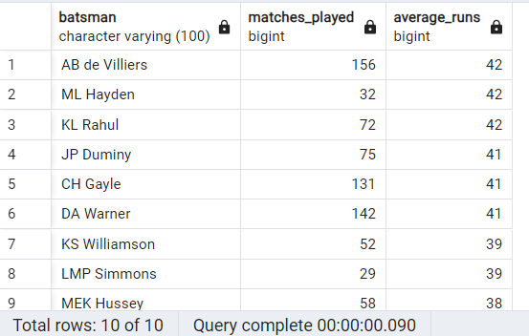 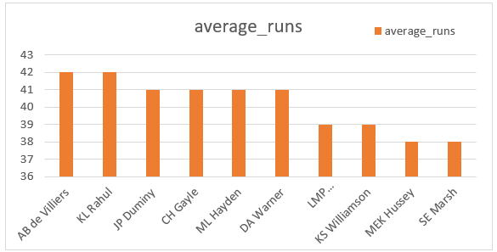

**/* Now you need to get 2-3 Hard-hitting players who have scored most runs in boundaries and have**

**played more the 2 ipl season. To do that you have to make a list of 10 players you want to bid in**

**the auction so that when you try to grab them in auction you should not pay the amount greater than**

**you have in the purse for a particular player.*/**

SELECT

batsman,matches_played,

total_runs,fours,sixes,

(fours * 4 + sixes * 6) AS total_boundary_runs,

CASE

WHEN total_runs = 0 THEN 0

ELSE ((fours * 4 + sixes * 6) / total_runs::float) * 100

END AS boundary_percentage

FROM

batsmen_stats

where

matches_played>28

ORDER BY

boundary_percentage DESC

limit 10;

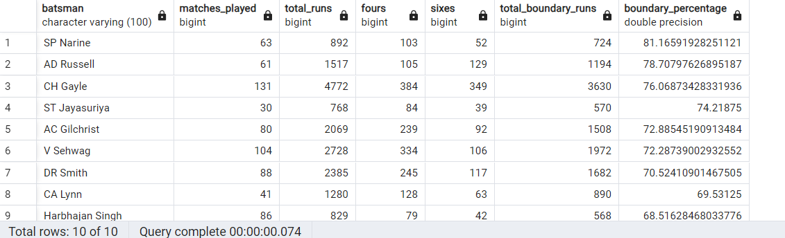 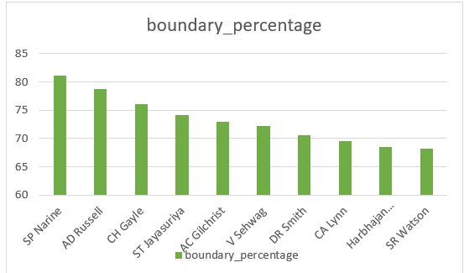

**/* Your first priority is to get 2-3 bowlers with good economy who have bowled at least 500 balls**

**in IPL so far.To do that you have to make a list of 10 players you want to bid in the auction so**

**that when you try to grab them in auction you should not pay the amount greater than you have in**

**the purse for a particular player.*/**

select bowler,matches_played , balls_delivered ,economy from bowler_stats

where balls_delivered>500

order by economy

limit 10;

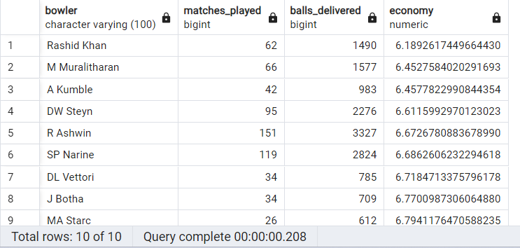 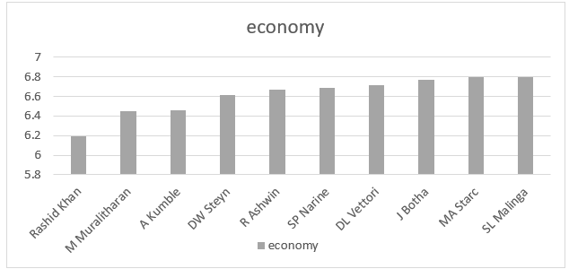

**/* Now you need to get 2-3 bowlers with the best strike rate and who have bowled at least 500 balls**

**in IPL so far.To do that you have to make a list of 10 players you want to bid in the auction so that**

**when you try to grab them in auction you should not pay the amount greater than you have in the purse**

**for a particular player.*/**

select bowler,matches_played,balls_delivered,strike_rate from bowler_stats

where balls_delivered>500

order by strike_rate

limit 10;

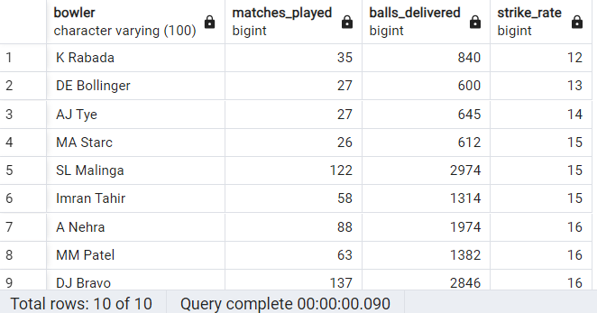 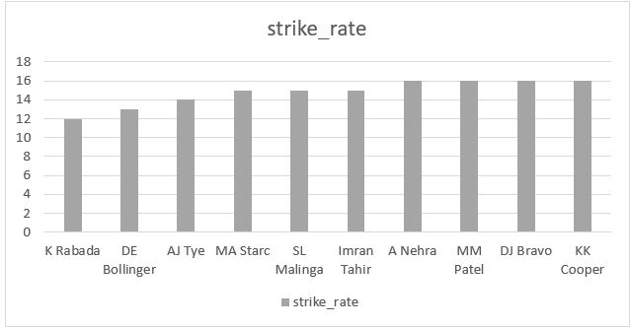

**/* Now you need to get 2-3 All_rounders with the best batting as well as bowling strike rate and who**

**have faced at least 500 balls in IPL so far and have bowled minimum 300 balls.To do that you have**

**to make a list of 10 players you want to bid in the auction so that when you try to grab them in**

**auction you should not pay the amount greater than you have in the purse for a particular player.*/**

**-- creating table for allrounders_stats**

create table allrounder_stats as select a.matches_played,a.batsman as allrounder,a.ball_played,a.total_runs,a.average_runs,a.strike_rate as batting_strikerate

,a.fours,a.sixes,b.balls_delivered,b.runs_conseed,b.economy,b.strike_rate as bowling_strikerate,b.wickets_taken

from batsmen_stats as a join bowler_stats as b

on a.batsman=b.bowler;

**--showig data of all rounder**

select * from allrounder_stats;

**-- selecting allrounder for team**

select allrounder,ball_played,batting_strikerate,balls_delivered, bowling_strikerate

from allrounder_stats

where ball_played>499 and balls_delivered>299

order by batting_strikerate desc,bowling_strikerate desc

limit 10;

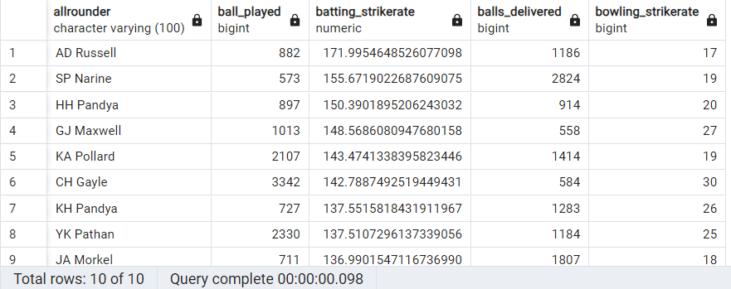 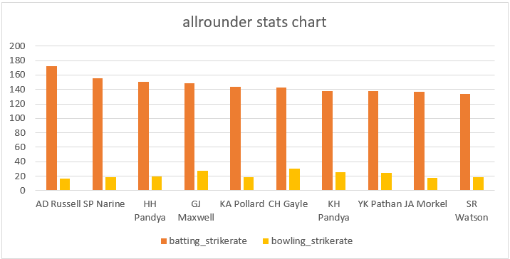

**/* selecting a wicketkeeper for a team*/**

**Explaination –** I am selecting a wicket keeper on the bases of the catches taken by a wicket keeper which is a most important factor of wicketkeeper as data given and I also used their strike rate.

So that the wicket keeper should contribute to team total runs with a good strike rate which help to score quick runs in t20 . I have taken top 30 data of catch taken and filter wicket

Wicket keeper using wicket keeper name list and then I take the strike rate data in order to get top 5 of result for target. Luckily I have 3 of them already in target list so I mention them as

Wicket keeper batsmen and remaining 2 I mentioned as wicket keeper.

select a.matches_played,a.batsman,a.strike_rate,b.catches_taken from batsmen_stats as a join (select fielder,count(dismissal_kind) as catches_taken

from ipl_ball where fielder in (select distinct(fielder) from ipl_ball where dismissal_kind='caught')

group by fielder

order by catches_taken desc limit 30

) as b on b.fielder=a.batsman

where a.batsman in ('MS Dhoni','KD Karthik','RV Uthappa','AB de Villiers','PA Patel','WP Saha','NV Ojha','AC Gilchrist','Q de Kock','RR Pant','KC Sangakkara')

order by strike_rate desc limit 5;

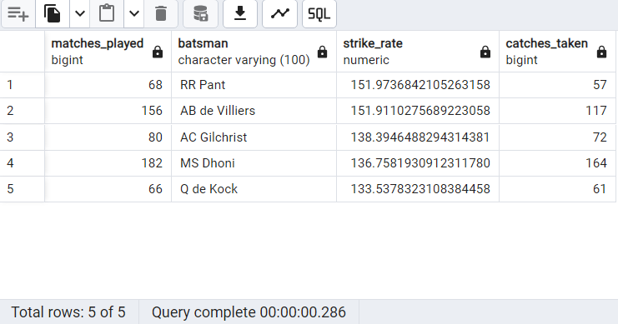 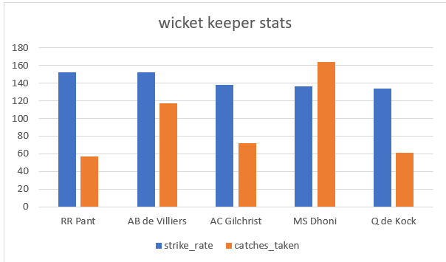

* Selected players to target in auction

|  |  |
| --- | --- |
| **Players name** | **Cateogery** |
| AD Russell | Allrounder |
| SP Narine | Allrounder |
| HH Pandya | Allrounder |
| GJ Maxwell | Allrounder |
| KA Pollard | Allrounder |
| CH Gayle | Allrounder |
| Harbhajan Singh | Allrounder |
| SR Watson | Allrounder |
| DJ Bravo | Allrounder |
| KH Pandya | Allrounder |
| YK Pathan | Allrounder |
| JA Morkel | Allrounder |
| JC Buttler | Batsman |
| KL Rahul | Batsman |
| V Sehwag | Batsman |
| JP Duminy | Batsman |
| ML Hayden | Batsman |
| DA Warner | Batsman |
| LMP Simmons | Batsman |
| KS Williamson | Batsman |
| MEK Hussey | Batsman |
| SE Marsh | Batsman |
| ST Jayasuriya | Batsman |
| DR Smith | Batsman |
| CA Lynn | Batsman |
| Rashid Khan | Bowler |
| M Muralitharan | Bowler |
| A Kumble | Bowler |
| DW Steyn | Bowler |
| R Ashwin | Bowler |
| DL Vettori | Bowler |
| J Botha | Bowler |
| MA Starc | Bowler |
| SL Malinga | Bowler |
| K Rabada | Bowler |
| DE Bollinger | Bowler |
| AJ Tye | Bowler |
| Imran Tahir | Bowler |
| A Nehra | Bowler |
| MM Patel | Bowler |
| KK Cooper | Bowler |
| AB de Villiers | Wicket keeper and batsmen |
| AC Gilchrist | Wicket keeper and batsmen |
| RR Pant | Wicket keeper and batsmen |
| MS Dhoni | wicket keeper |
| Q de Kock | wicket keeper |

Note*- I donated a wicket keeper and batsmen because they are already selected in team but I get them in wicket

Table result also

-- Additional questions

**--creating table deliveries**

create table deliveries (id int,inning int,over int,ball int,batsman varchar(100),non_striker varchar(100),bowler varchar(100),batsmen_runs int,extra_run int,total_runs int,is_wicket int,dismissal_kind varchar(100),pyaler_dismissal varchar(100),fielder varchar(100),extras_type varchar(100),batting_team varchar(100),bowling_team varchar(100) );

**--copy data from csv in ipl ball**

copy deliveries from 'C:\Program Files\PostgreSQL\16\data\copy data\IPL_Ball.csv' delimiter ',' csv header;

**--showing data of iplball**

select * from deliveries;

**--creating table ipl maches**

create table matches (id int,city varchar(100),date date,player_of_match varchar(100),venue varchar(200),neutral_vanue int,team1 varchar(100),team2 varchar(100),toss_winnwe varchar(100),toss_decision varchar(100),winner varchar(100),result varchar(100),result_margin int,eliminator varchar(100),method varchar(100),umpire1 varchar(100),umpire2 varchar(100));

**--copy data from csv in ipl maches**

copy matches from 'C:\Program Files\PostgreSQL\16\data\copy data\IPL_matches.csv' delimiter ',' csv header;

**--showing data of ipl_maches**

select * from matches;

**Q1- Get the count of cities that have hosted an IPL match?**

select count(distinct city) as count_ofcities from matches

where NOT city ='NA';

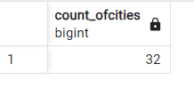

**Q2- Create table deliveries_v02 with all the columns of the table ‘deliveries’ and an additional**

**column ball_result containing values boundary, dot or other depending on the total_run**

**(boundary for >= 4, dot for 0 and other for any other number)**

**(Hint 1 : CASE WHEN statement is used to get condition based results)**

**(Hint 2: To convert the output data of the select statement into a table, you can use a**

**subquery. Create table table_name as [entire select statement].**

CREATE TABLE DELIVERIES_V02 AS

SELECT id,inning,over,ball,batsman,non_striker,bowler,batsmen_runs,extra_run,total_runs,is_wicket,dismissal_kind,

pyaler_dismissal as player_dissmisal,fielder,extras_type,batting_team,bowling_team ,CASE WHEN total_runs >= 4 THEN 'boundary' WHEN total_runs = 0 THEN 'dot' ELSE 'other' END AS ball_result

FROM DELIVERIES;

**--selecting deliveries v02 data**

select * from DELIVERIES_V02;

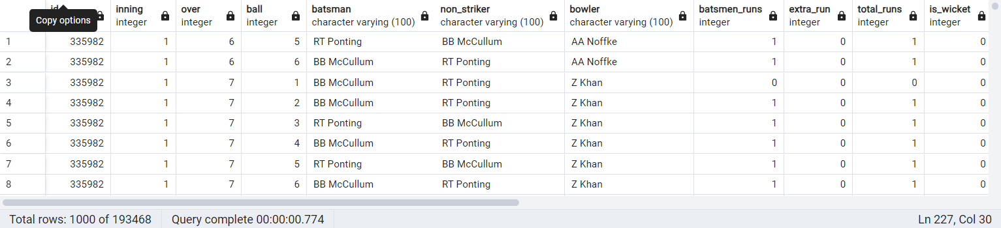 note*- other columns are not able to capture in this screen shot

**Q3- Write a query to fetch the total number of boundaries and dot balls from the**

**deliveries_v02 table**

SELECT

SUM(CASE WHEN ball_result = 'boundary' THEN 1 ELSE 0 END) AS total_boundaries,

SUM(CASE WHEN ball_result = 'dot' THEN 1 ELSE 0 END) AS total_dot_balls

FROM deliveries_v02;

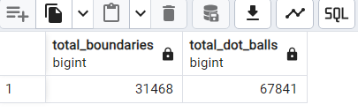

**Q4-Write a query to fetch the total number of boundaries scored by each team from the**

**deliveries_v02 table and order it in descending order of the number of boundaries**

**scored**

select distinct(batting_team) as team_name , SUM(CASE WHEN ball_result='boundary' then 1 else 0 END) as total_boundaries

from DELIVERIES_V02

GROUP BY batting_team

order by total_boundaries desc;

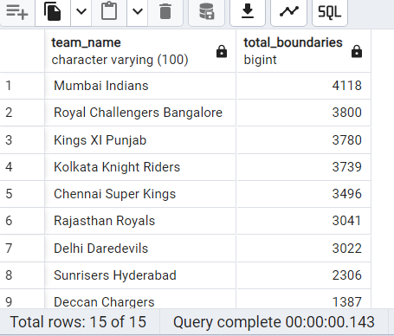

**Q5 -Write a query to fetch the total number of dot balls bowled by each team and order it in**

**descending order of the total number of dot balls bowled**.

select distinct(batting_team) as team_name , SUM(CASE WHEN ball_result='dot' then 1 else 0 END) as total_dotballs

from DELIVERIES_V02

GROUP BY batting_team

order by total_dotballs desc;

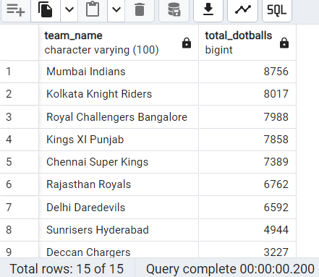

**Q6-Write a query to fetch the total number of dismissals by dismissal kinds where dismissal**

**kind is not NA**

select count(dismissal_kind)

from deliveries

where NOT dismissal_kind='NA';

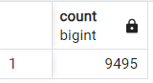

**Q7 Write a query to get the top 5 bowlers who conceded maximum extra runs from the**

**deliveries table**

select bowler,sum(extra_run) as extra_runs

from deliveries

group by bowler

order by extra_runs desc

limit 5;

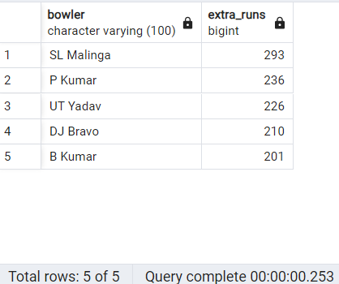

**Q8- Write a query to create a table named deliveries_v03 with all the columns of**

**deliveries_v02 table and two additional column (named venue and match_date) of venue**

**and date from table matches**

create table deliveries_v03 as select d.*,m.venue,

m.date as match_date

from DELIVERIES_V02 as d join matches as m

on m.id=d.id;

select * from deliveries_v03;

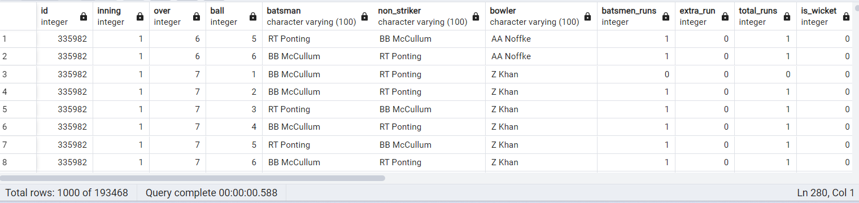 note*- other columns are not able to capture in this screen shot

**Q9-Write a query to fetch the total runs scored for each venue and order it in the descending**

**order of total runs scored**

select venue,sum(total_runs) as total_runs

from deliveries_v03

group by venue

order by total_runs desc;

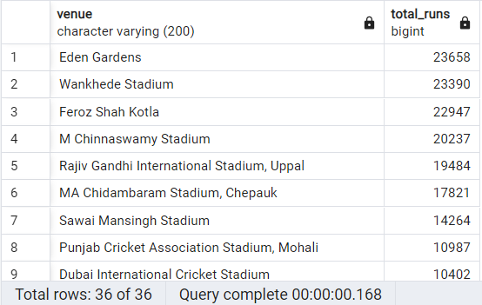

**Q-10 Write a query to fetch the year-wise total runs scored at Eden Gardens and order it in the**

**descending order of total runs scored**

select extract(year from match_date) as year ,sum(total_runs) as total_runs from deliveries_v03

where venue = 'Eden Gardens'

group by extract(year from match_date)

order by total_runs desc;

